**Ansible installation and Adhoc commands**

**Pre-request:**

* Need 3 instances or at least 2 instances for best practice.
* Create separate user and give full access to run the commands.
* Configure password less login from Controller to Management server.

**Un command PremitRootlogin and password authentication and restart sshd.**

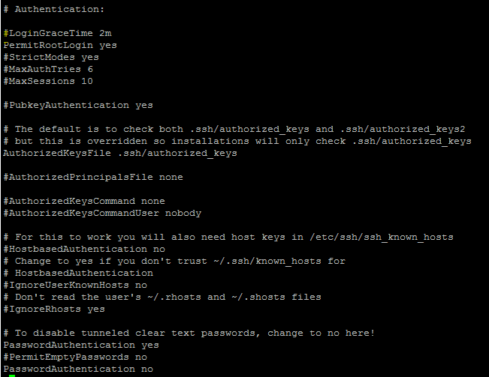

**Install the ansible packages.**

wget http://dl.fedoraproject.org/pub/epel/epel-release-latest-7.noarch.rpm

$ sudo rpm -ivh epel-release-latest-7.noarch.rpm

$ sudo yum install ansible -y

$ ansible --version

Edit the /etc/ansible/ansible.cfg

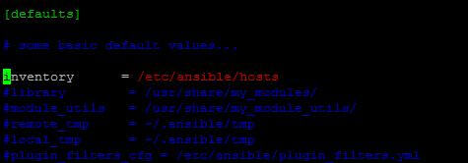

Add the target machines into /etc/ansible/hosts file.

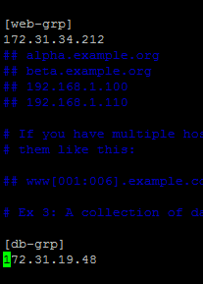

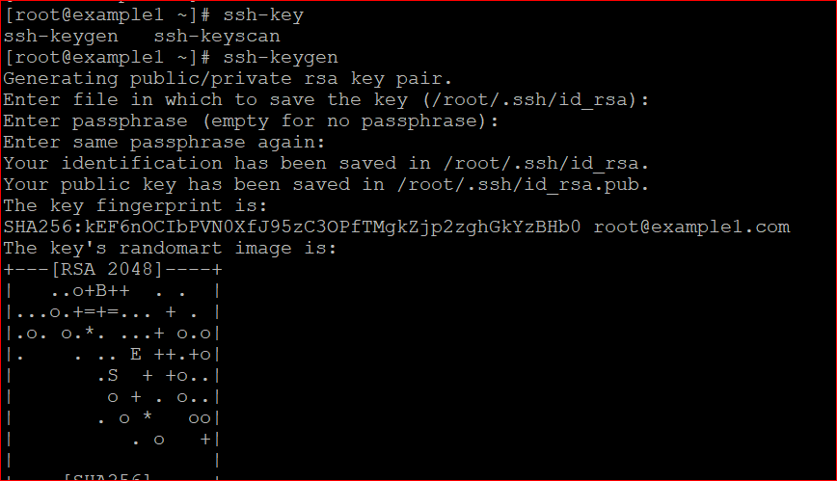

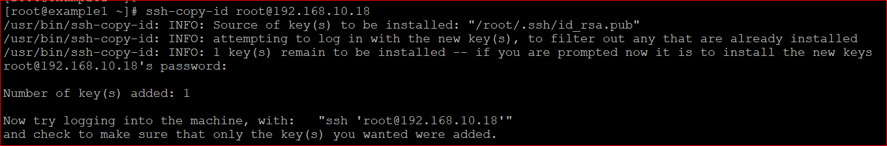

After adding server in host file now check the ping status of management or target nodes.

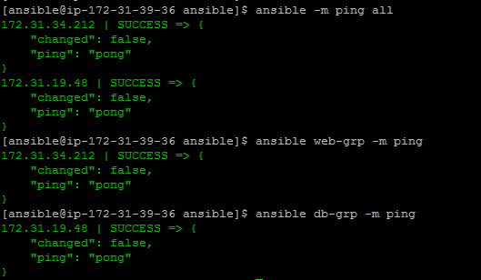

Command to check how many hosts available in a target group.



Command to copy a file.

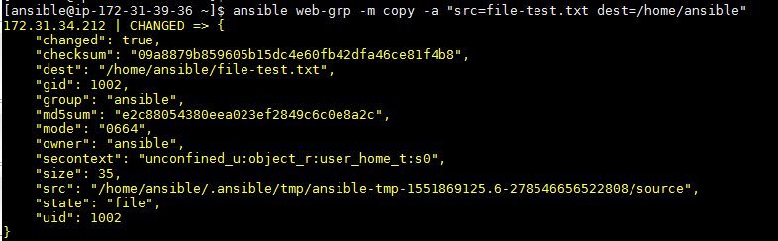

Command to create a file.

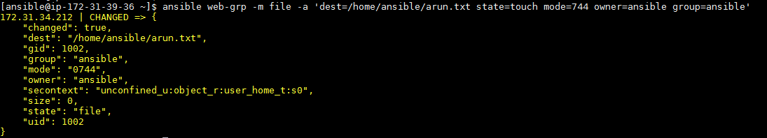

Command to delete a file and verify from the controller node.

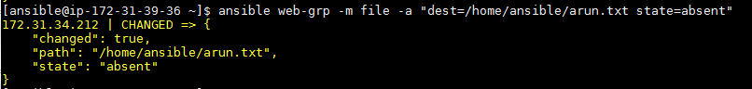

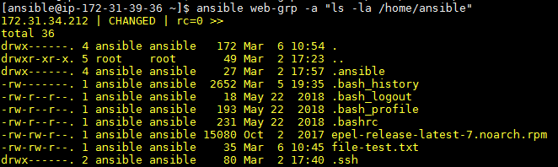

Command to create directory

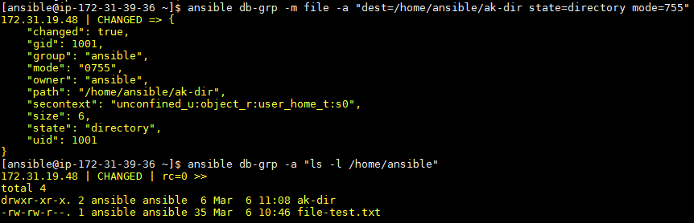

Command to delete directory

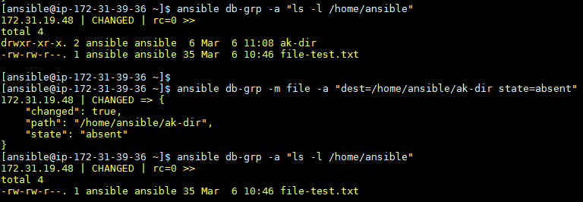

Command to create user and verify from controller machine.

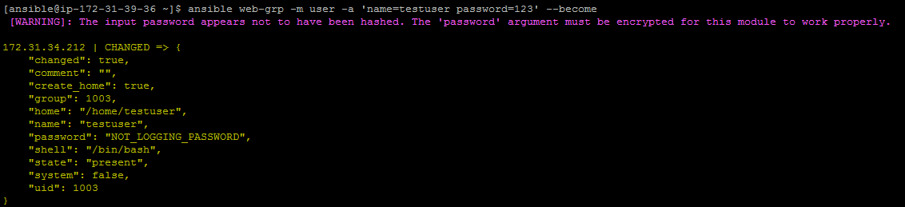



Command to delete user.

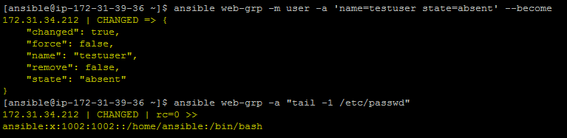

Command to check specific packages installed or not in target machine.

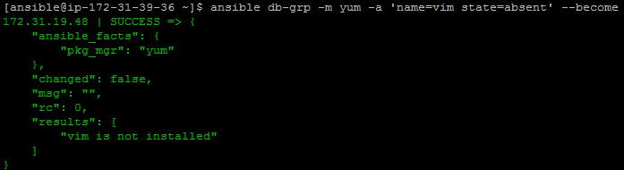

Command to install specific packages.

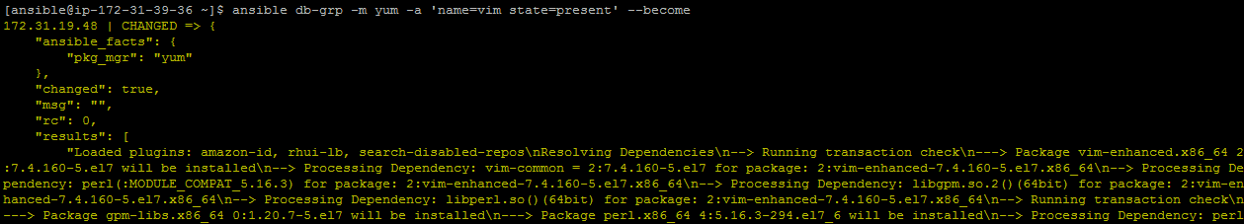

Command to remove packages.

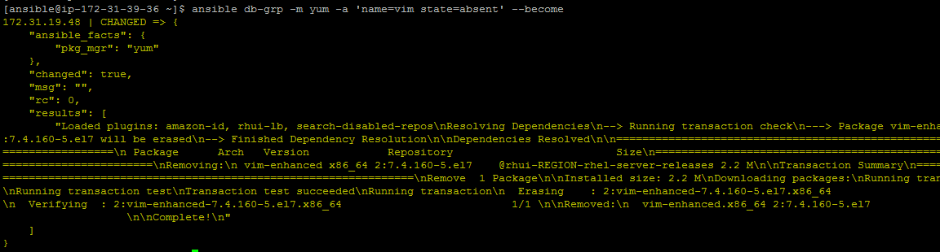

Command to check updates of the packages.

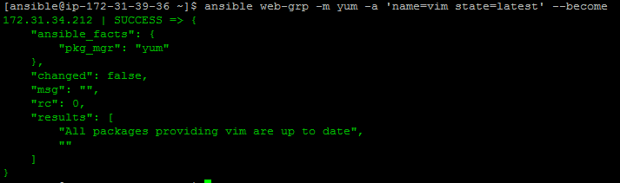

Command to install httpd packages.

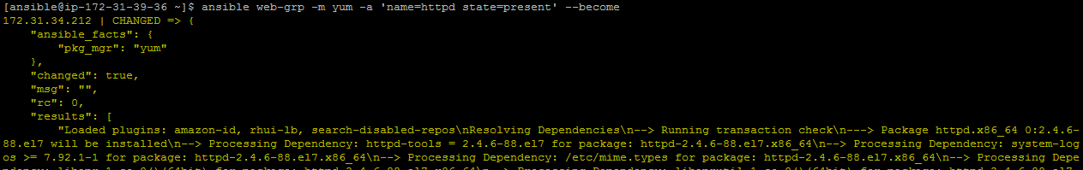

Command to check start httpd service.

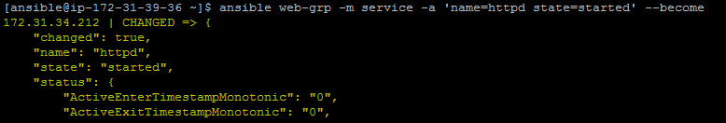

Copy the index.hmtl file into root directory.

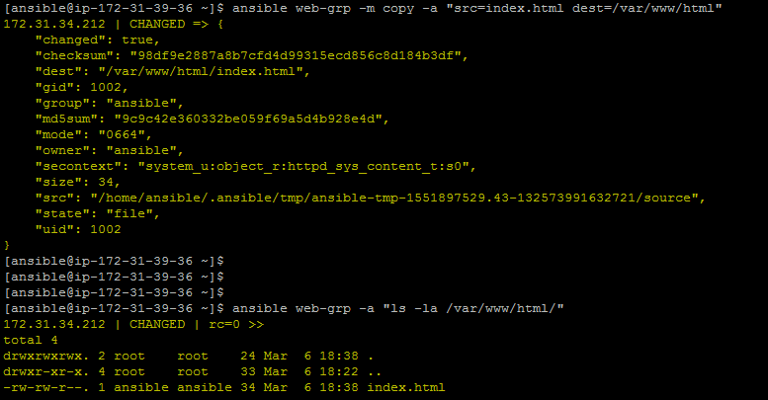

Command to stop the http service.

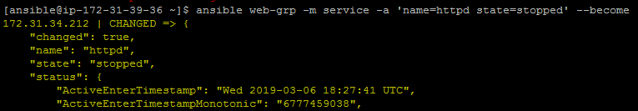

Command to restart the service.

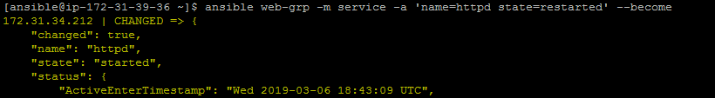

Command to check kernel info of target machine.

